Project Design Phase-II
Technology Stack (Architecture & Stack)

Date | 16 February 2026
Team ID | LTVIP2026TMIDS35442
Project Name | DocSpot: Seamless Appointment Booking for Health
Maximum Marks | 4 Marks

Technical Architecture:
Data Flow:

- User interacts with React frontend
- Axios sends HTTP requests to Express backend
- Express routes handle requests via controllers
- Controllers interact with MongoDB via Mongoose models
- JWT middleware protects authenticated routes
- Multer handles file uploads to uploads folder
- Responses sent back to frontend

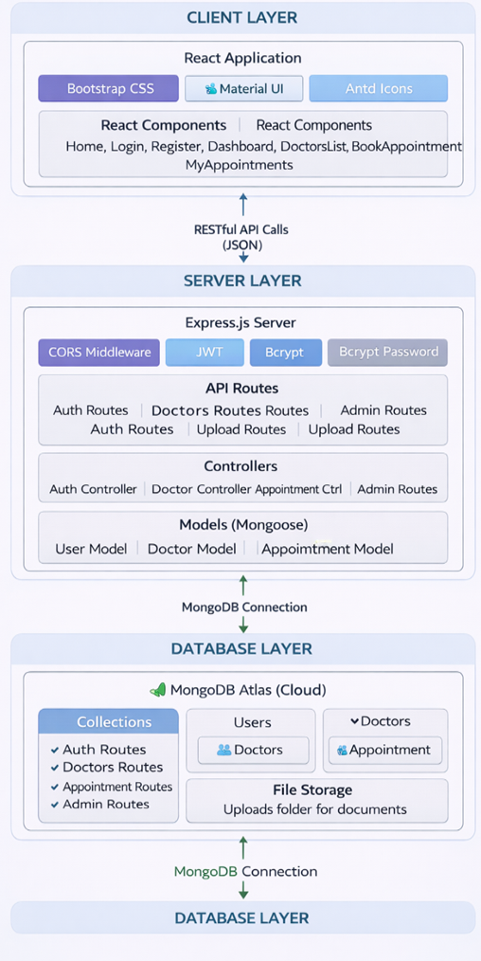
Table-1 : Components & Technologies:
S.No | Component | Description | Technology
1. | User Interface | Web application interface for patients, doctors, and admin | React.js 18.2.0
2. | UI Component Libraries | Styling and UI components for better user experience | Bootstrap 5.3, React-Bootstrap 2.10, MDB React UI Kit 8.0
3. | HTTP Client | Communication between frontend and backend | Axios 1.6
4. | Application Logic - Backend | Server-side logic, API endpoints, business logic | Node.js 22.18, Express.js 4.18
5. | Authentication | User authentication and authorization | JWT (jsonwebtoken 9.0), Bcryptjs 2.4
6. | Database | Primary data storage | MongoDB 7.5 (Mongoose ODM)
7. | Cloud Database | Hosted database service | MongoDB Atlas
8. | File Storage | Storage for uploaded medical documents | Local filesystem (uploads folder) with Multer 1.4
9. | Password Encryption | Secure password hashing | Bcryptjs 2.4
10. | Environment Configuration | Manage environment variables | Dotenv 16.3
11. | CORS | Cross-origin resource sharing | CORS 2.8
12. | Development Tools | Hot reloading for development | Nodemon 3.0
13. | Date/Time Handling | Parse and format dates | Moment.js
14. | Icons | Icon library for UI | React Icons
15. | Infrastructure (Server) | Application deployment | Localhost (Development)

Table-2: Application Characteristics:
S.No | Characteristics | Description | Technology
1. | Open-Source Frameworks | All frameworks used are open-source | React.js, Node.js, Express.js, MongoDB, Bootstrap, JWT, Bcrypt
2. | Security Implementations | • Password hashing with bcrypt  • JWT tokens for authentication  • Protected routes with middleware  • Role-based access control (Patient/Doctor/Admin)  • Environment variables for secrets  • Input validation and sanitization  • CORS configuration  • File upload type restrictions | Bcryptjs 2.4, JWT, Express Middleware, CORS, Multer
3. | Scalable Architecture | • Client-server architecture with separation of concerns  • Stateless JWT authentication allows horizontal scaling  • Modular code structure (controllers, models, routes)  • MongoDB Atlas can scale with data growth  • Indexed database collections for performance  • React components reusable and modular | MERN Stack (MongoDB, Express, React, Node.js)
4. | Availability | • MongoDB Atlas provides 99.9% uptime  • Application available 24/7 on localhost  • Graceful error handling prevents crashes  • Database connection retry on failure | MongoDB Atlas, Express error handling
5. | Performance | • Database indexing for faster queries  • JWT tokens reduce database lookups  • Efficient MongoDB queries with Mongoose  • React virtual DOM for fast rendering  • API response time < 500ms | MongoDB indexes, JWT, React virtual DOM

References:
- https://reactjs.org/
- https://nodejs.org/
- https://expressjs.com/
- https://www.mongodb.com/atlas
- https://mongoosejs.com/
- https://jwt.io/
- https://github.com/axios/axios
- https://react-bootstrap.github.io/
- https://mui.com/
- https://ant.design/

